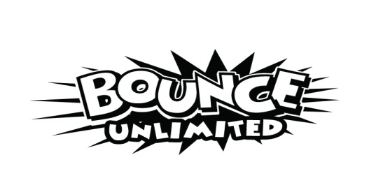
SAFETY RULES TO PROTECT YOUR GUESTS AND OUR BOUNCERS
HOW MANY OCCUPANTS AT A TIME?
8 yrs and under (6-8)
9-12 yrs (5-6)
Older Teens (3-4)
Adults (1-2)
ADULT SUPERVISION Accidents are more likely to happen when occupants are not being properly supervised.
KIDS OF LIKE SIZES Be very watchful when bigger children are in with smaller ones.
NO SHOES
NO FOOD OR DRINKS, gum, cotton candy, etc in or around the bounce house.
NO SILLY STRING The chemicals in silly string will ruin the vinyl in our inflatable bouncers, the damage is not repairable. Please don't plan to have silly string at your party if you are renting a inflatable. If silly strings ruins one of our inflatable jumps and/or slides the renter WILL be responsible for the full cost of replacement.
NO CLIMBING on (or bouncing against) the walls, bumpers, roof, or netting.
NO FLIPS, DIVING, WRESTLING, OR ROUGH PLAY Rough play and flips can lead to knocked noggins or worse. Encourage bouncers to keep some space between each other.
ABSOLUTELY NO JUMPING, DIVING, OR FLIPPING DOWN THE SLIDES Occupants MUST go down feet-first in a seated position, one-at-a-time. No climbing up the slide the wrong way.
NO MOVING OR ALTERING THE INFLATABLE, the anchoring system, or any of it’s accessories.
THBLOWER SHOULD NOT BE TURNED OFF Units deflate very quickly when power is removed. Avoid sharing the circuit with any other item that together could overload and trip a circuit, causing unintentional deflation. If the inflatable bouncer has power and will not stay inflated make sure all deflation zippers and tubes are closed. If after the initial checks the problem has not been corrected, give us a call. We are committed to your enjoyment, but need notice to fix problems that cannot be predicted.
KEEP GUESTS AWAY FROM THE BLOWER at all times.
IT IS UNSAFE TO OPERATE THE UNIT in lightening, downpours, or winds in excess of 15 mph. Remove occupants and deflate the unit by unplugging the blower.
Please TURN THE UNIT OFF when it is not in use or being supervised.

HAVE FUN!!!

